CURRICULUM VITTAE
---------------------------------------

PERSONAL DATA

NAME: HISHAM MOSTAFA KAMEL IMAM  NATIONALITY: EGYPYIAN  DATE OF BIRTH: MAY 27th 1962  PLACE OF BIRTH: MADISON-WISCONSIN-USA  MARITAL STATUS: MARRIED & HAS 3 CHILDREN  OCCUPATION: PROFESSOR OF DIAGNOSTIC RADIOLOGY, ASSIUT UNIVERSITY HOSPITAL, ASSIUT, EGYPT. | 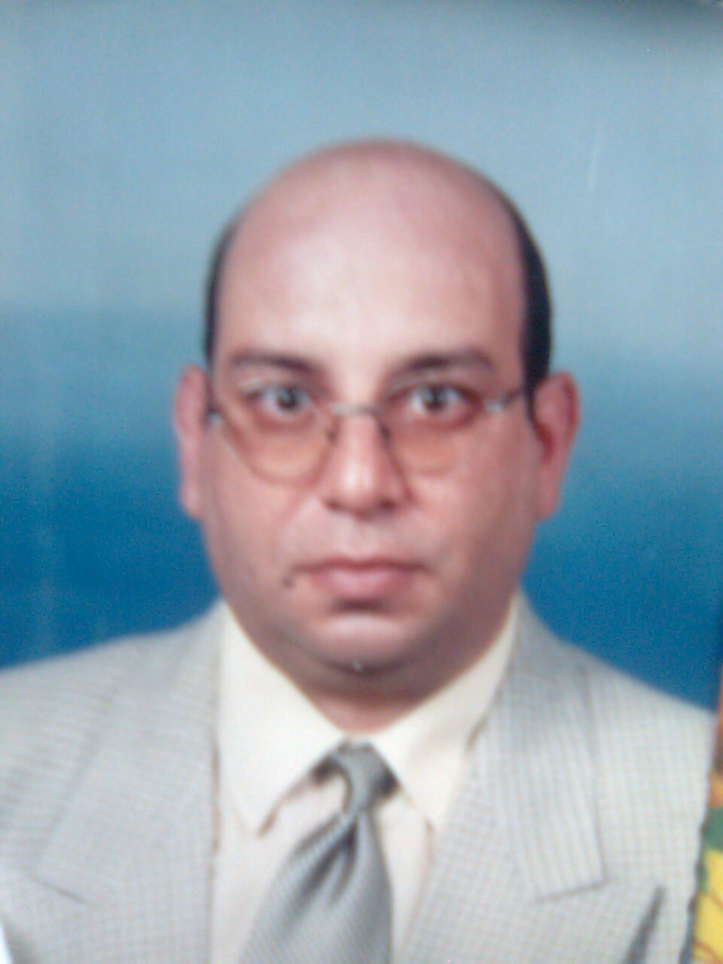

QUALIFICATIONS
-------------------------
- M.B.B.Ch., ASSIUT UNIVERSITY, September 1985 with final grade “GOOD”
- M.Sc., ASSIUT UNIVERSITY, June 1990 with final grade “ VERY GOOD”
- M.D. ASSIUT UNIVERSITY, June 1996
- MRI Diploma CAEN-ROUEN UNIVERSITIES. FRANCE.
5. Diploma in Radiology and Medical Imaging CAEN UNIVERSITY. FRANCE

PRACTICAL EXPERIENCE
- House officer, Assiut University Hospitals for one year from March 1986 to Feb.87
- Resident of Radiology for 4 years from March 1987 to Feb.1991 including one year in the department of Medicine.
- Assistant lecturer in the Radiology department Assiut University Hospital from March 1991 to June 1996.
- Physician of Radiology at Neuroradiology and interventional Radiology Department, Caen University Hospital – France for 2 years from Feb.1993 to December 1994.
- Lecturer of Radiology at Assiut University Hospital in July 1996.
- Honorary Registrar in Western General Hospital, Radiology Department- Edinburgh University, UK. For one year from November 1997 to November 1998.
- Honorary Registrar of radiology in Derriford Hospital, Plymouth, UK between April 2000 till August 2001. ( Post-Doctoral Fellowship).
- Assistant Professor of Diagnostic Radiology from March 2002- March 2007.
- Professor of Diagnostic Radiology- Faculty of Medicine- Assiut University; from April 2007 till current time.

Responsibilities while being resident and assistant lecturer in Assiut Uni. Hosp. Included
- Dealing with trauma patients for doing urgent conventional x-ray and abdominal ultrasound.
- Performance of almost all special techniques under image intensifier control e.g. all barium examinations, myelography, sialography, lymphangiography, and percutaneous transhepatic cholangiography.
- Shared in the diagnosis of routine conventional x-ray and CT for all departments and clinics.
- Shared in the research work and scientific meeting in the department.

Responsibilities during working in Caen University Hospital in France included
- The performance and diagnosis of routine CT and MRI had done in this department.
- The performance of the routine 4 vessels cerebral angiography as a diagnostic procedure or before vascular interventional dilatation or embolization.
- Taking emergency night shift for performance of urgent arteriography and myelography in emergency cases as cerebral stroke, and fracture spine.

While being in Caen University Hospital Attendance of advanced courses for obtaining a qualified certification included.
- A University Diploma of MRI from Rouen-Caen Universities.
- A Specialized Training Diploma in Radiology and Medical Imaging from Caen Uni.

After being back to Assiut Uni. Hosp. in April 1995 I shared in the initiation and running of the new Digital Subtraction Unit. The work included performance of all vascular diagnostic procedures, and performance of some vascular interventional procedures including the following:
- Embolization of bronchial arteries in haemoptysis.
- Embolization of renal arteries preoperatively in renal tumors and haematuria.
- Angioplasty dilatation of renal arteries in renal hypertension.
- Angioplasty dilatation of aortoiliac and femoral arteries stenosis.

Responsibilities while being in Western General Hospital In Edinburgh, Scotland.
-Sharing in the routine work of CT and it all applications.
-Sharing in the routine abdominal sonography.

Responsibilities while being in Derriford Hospital in Plymouth, UK.
-Sharing in the routine work of MRI, with special concern in the muscloskeletal applications.
-Sharing in the routine work of spiral CT, with special concern in its abdominal and pelvic applications.
- Sharing in the routine abdominal sonography.

Teaching Experience:

Undergraduate teaching for Medical students ( 5th and 6th years)
- Sharing in post graduate teaching for pre intern graduates.
- Sharing in post graduate teaching of residents of different specialties on related different diagnostic techniques.
- Sharing in the teaching of post-graduate students applying (Master and M.D. Degrees in Diagnostic Radiology).
- Sharing in the scientific meetings and seminars of the Diagnostic Radiology Department.
- Sharing in the scientific meetings of other hospital departments including: Orthopedic, Urology, Ophthalmology, General Surgery, ENT, Oncology, Pediatrics, Cardiology, Tropical Medicine, Neurosurgery, Vascular surgery and Others.

Other Scientific Activities:

- Sharing in the workshops organized by Quality Assurance Unit of Assiut Faculty of Medicine for post graduate teaching.
- Organization of the 1st and 2nd conference of Diagnostic Radiology in Assiut University, December 2005, June 2006.
- Sharing in the workshop of the 1st conference of Diagnostic Radiology in Assiut University, December 2005.
- Sharing in the workshop of the 2nd conference of Diagnostic Radiology in Assiut University, June 2006.
- Sharing and presentation of scientific papers and lectures in many national and international conferences.
- Organization (Head of the Organizing Committee of Radiology Conference on Clinical Applications of MSCT in Assiut University, December 2009).
- Sharing in the running of different specialized units of the department.
- Supervisor and clinical manager of Al-Amal Private Radiology Center, which includes (MRI Unit, 64 MDRCT Unit, and Diagnostic Ultrasonography and Doppler Unit) since 2005.

Researches
- M.Sc. Thesis “Role of double contrast barium meal in Upper Gastrointestinal Lesions”.
- M.D. Thesis “Role of imaging modalities (CT and MRI) in evaluation of paranasal sinuses lesions”.
- MRI Diploma Thesis “Functional MR, clinical application for the anatomic determination of the motor area”.

Published Papers
- “Bronchial artery embolization in life threatening haemoptysis” published in The Egyptian Journal of Radiology and Nuclear Medicine Vol 45 Dec 96.
- “Percutaneous Transcatheter Arterial Embolization for Management of Post-operative Renal Haemorrahage” published in The Egyptian Journal of Radiology and Nuclear Medicine Vol 31, Second Part, June 2000.
- “Magnetic Resonance Urography in the Assessment of Obstructive Uropathy in Patients with Renal Failure” published in The Egyptian Journal of Radiology and Nuclear Medicine Vol. 32, No. 3, (September): 831-835, 2001.
- “Spiral (Helical) CT Angiography of Iliofemoral Occlusive Diseases” published in The Egyptian Journal of Radiology and Nuclear Medicine Vol.,31, No. 2, June: 465-474, 2000.
- “Management of Massive, Life Threatning Bladder Haemorrhage Associated with Bladder Cancer” published in The Egyptian Journal of Radiology and Nuclear Medicine Vol. 31, No. 2, (June): 589-602, 2000.
- Early Diagnosis of Rheumatoid Cervical Myelopathy: Neurophysiological Study and Magnitic Resonance Imaging” published in The Official Journal of The Egyptian Society of Neurology, Psychiatry and Neurosurgery, May 2001.
- “Bronchial Artery Embolization in The Management of Haemoptysis Secondary to Pulmonary TB” published in The Egyptian Journal of CHEST/ April 2002.
- The Management of Penile Fracture Based on Clinical and Magnetic Resonance Imaging Findings: British Journal of Urology; August 2005- Vol.(96) issue (3), Page 373-377.
- CT versus C-ARM Fluoroscopy Guided Celiac Plexus Block in Upper Abdominal Cancer Pain. The Journal of the Egyptian Society for Management of Pain JESMP, Vol. (24), No. (2), October 2006: 113-121.
- Urinary Bladder Carcinoma: MR versus CT Evaluation. Assiut Med.J. Vol. (29), No. (3), September, 2005.
- The Role of Combined Spiral CT Pulmonary Angiography and Lower Limb Venography in Diagnosis of Pulmonary Embolism and Deep Venous Thrombosis. Cairo Medical J. Vol (72), No (4), Dec. 2004.
- Role of Diffusion-Weighted MR imaging Brain Tumors: Correlation with Conventional MR Imaging. The Egyptian J Of Radiology and Nuc. Med. November 2003.
- Early Experience with Uterine Artery Embolization in Treatment of Symptomatic Uterine Fibroids. The Journal of the Egyptian Society of Obstetrics and Gynecology; 30: (4,5,6), 2004.
- Role of STIR Sequence in Vertebral Metastases. The Egypt. J of Radiology & Nuc. Med.: 34(4), 2003.
- Tendon Transfer around the Shoulder in Obstetric Brachial Plexus Paralysis: Clinical and Computed Tomography Study. Journal of Paediatric Orthopaedics; 26:5, 2006, pp 641-646.
- Clinical and Radiological Evaluation of Respiratory Complications in Traumatized Patients at Assiut Univeristy Hospital Trauma Center. The Egyptian Journal of Chest Diseases & Tuberculosis; 54 (4), 2005.
- The Role of MR Imaging in Evaluation of Patients with Unilateral Proptosis. The Egyptian J of Radiology and Nuc. Med.; 35 (1): 101-110, 2004.
- Magnetic Resonance Imaging in the Evaluation of Male Stricture Urethera. The Egyptian J of Radiology and Nuc. Med.; 35 (1): 415-422, 2004.
- Role of MRI and MRU in Evaluation of Lion Pain during Pregnancy. The Egyptian J of Radiology and Nuc. Med.; 35 (3): 2004.
- Role of Local Periprostatic Nerve Block versus Intra-rectal Lidocaine GEL in Pain Reduction during Trans-Rectal Ultrasound-Guided Biopsy of the Prostate. Oral presentation in the Scientific Sessions of the 13th European Symposium on Urogenital Radiology.
- CT versus MRI in the Assessment of Renal Masses. Poster presentation in the 13th European Symposium on Urogenital Radiology ESUR 06.
- Utility of Combined CT Venography and Pulmonary Angiography (CTVPA) in Clinically Suspected Thromboembolic Disease. Egyptian Journal of Chest, vol 56(4); page 132-145, Oct 2007
- CT Venography versus Doppler Ultrasonography in Suspected Pulmonary Embolism among Acute Exacerbation COPD Patients. Egyptian J of Bronchology; 2 (2), 272-280, 2008.
- Evaluation of Recently Validated Non-invasive Formula Using Basic Lung Functions as New Screening Tool for Pulmonary Hypertension in Idiopathic Pulmonary Fibrosis Patients. Annals of Thoracic Medicine, vol 4(4); page 187 - 196 Oct - Dec 2009. DOI: 10.4103/1817-1737.56013.

Fields of Interest & Expert:
- Clinical Applications of Multi-Slice CT.
- Application of conventional angiography with its subsequent vascular interventional radiology.
- Application of all MRI techniques.
- Application of all spiral CT techniques.

Referees

Prof. Mostafa M Kamal
President of Assiut University
Professor of Organic Chemistry- Faculty of Science.
Assiut University
Assiut- Egypt
Tel: 002 088 2357007
Fax: 002 088 2354130

Prof. Maher A AlAsal
Dean of Faculty of Medicine – Assiut University
Professor of Orthopaedic Surgery
Assiut University Hospitals
Assiut- Egypt
Tel: 002 088 2315222
Fax: 002 088 2333327

Prof. Mohamed Shalaby
Professor of Urology
Assiut University Hospitals
Assiut- Egypt
Fax: 002 088 2313970

- Prof.Dr. Patric Courteoux.
Professor of Diagnostic Radiology.
Caen –France
C.H.U. De Caen
Avenue De La Cote De Nacre 14033 CAEN CEDEX

- Dr Sami Mousa (FRCR, FRCS).
Consultant Radiologist
Scottish Lithotriptor Center
Western General Hospital
Crewe Road South
Edinburgh- Scotland
Fax: 0131 537 1020

- Dr J N Perry (FRCR).
Surg. Cdr. RN
Consultant Radiologist.
Imaging Directorate,
Derriford Hospital,
Plymouth PL6 8DH
UK

